**2-1 Assignment: CRUD in MongoDB**

Name: Matthew Rix

Class: CS-340-T1193

Date: 9/7/2022

**Step 1**

Navigated to the datasets folder and imported the inspections directory

**Step 2**

Verified the load

**Step 3**

Inserted a document with the key value pairs from the prompt

**Step 4**

Used the .distinct with the .length commands for part A, the difference as shown by the screenshot is that AUSTIN 2012’s date is not generated but looks manually entered and only contains the month (in string format) ,day, and year. Meanwhile, ACME Explosives has the generated date and timestamp with time zone. For part C I defined a variable cursor so iterate through all the result and Violation Issued key pairs and then assigned to an array and used the .length to get the count.

**Step 5**

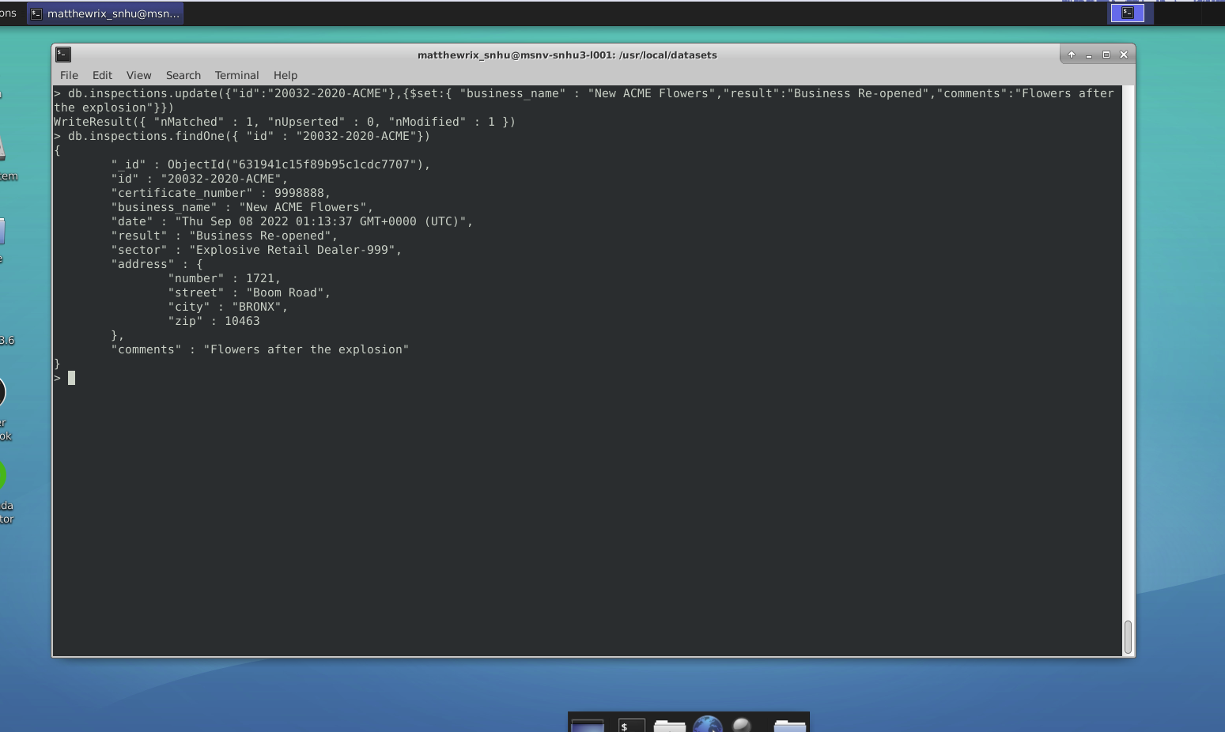

Updated the document with the update command.

**Step 6.A**

This screenshot shows the first two entries to verify that zip did not already equal 76114

This screenshot shows the command used and the top two as verification of successful change

**Step 6.B**

This first screen shot shows the first two results that match the criteria

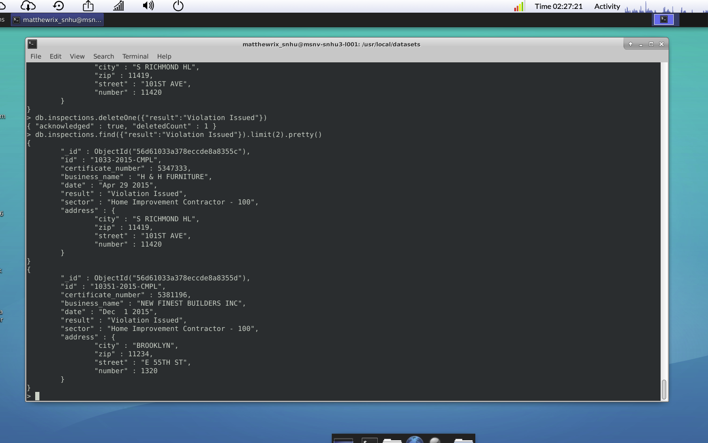

This screenshot shows the command for deleting the first and the verification that it is now gone and the previous second result is now the first result.